**Part III: Chapter 3: Descriptive Statistics**

**Task 1: Fill in the following chart concerning the measures of center for the variables:**

|  |  |  |
| --- | --- | --- |
| **Variable** | **Best Measure of Center** | **Explain Why** |
| **Age** |  |  |
| **FEV** |  |  |
| **Height** |  |  |
| **Sex** |  |  |
| **Smoking Status** |  |  |

**Task 2: Use Statdisk to get the descriptive statistics for FEV and height. Insert these results in the space below.**

**Task 3: Make a modified boxplot of the FEV data. Outliers are shown with an asterisk. Are there any outliers in this data? Identify the outliers and explain below how this determination is made. (You will need to sort the FEV column in order to identify the outliers since there is more than one.)**

**Task 4: Statdisk is able to produce side-by-side boxplots to facilitate comparison of data. By disaggregating the FEV data into a set for smokers and a set for nonsmokers and then doing side-by-side boxplots of the FEV data we get the following graph:**

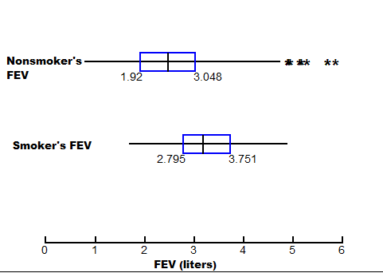

**This graph shows that, for our data set, the forced expiratory volume of the smokers was on average greater than the FEV for nonsmokers. Does this observation make sense? How can you explain this result? Have a discussion about the meaning of this result. You may need to review the biological meaning of FEV at this link:** [**http://www.ncbi.nlm.nih.gov/pmc/articles/PMC1844423/pdf/brmedj02547-0042.pdf**](http://www.ncbi.nlm.nih.gov/pmc/articles/PMC1844423/pdf/brmedj02547-0042.pdf)

**Also, be sure to consider how the other factors such as age and body size (represented by the height variable) influence FEV. Write a paragraph explaining your discussion conclusions.**

**Task 5: Determine the z score for a height of 62 inches and explain what this number represents.**